Roll No: 2103064

Lab Performance Evaluation 02
Lab Task Q1
Question: Circuit Design with STM32 based embedded system which takes 2 inputs via push down button through PA pin and connect a yellow LED in PB pin for output. When either any button is pushed the LED will turn on, turn off in case of both buttons are pressed.

Solution (Code):
// Roll-2103064
#include "stm32f10x.h"
void gpio_set()
{
RCC->APB2ENR |= (1UL<<2)|(1UL<<3);
GPIOA->CRL &= ~((15UL<<4)|(15UL<<8));
GPIOA->CRL |= (4UL<<4)|(4UL<<8);

GPIOB->CRL &=~(15UL<<4);
GPIOB->CRL |=(3UL<<4);
}
int main()
{
gpio_set();
while(1)
{
int x=!(GPIOA->IDR&(1UL<<1));
int y=!(GPIOA->IDR&(1UL<<2));
if((x||y)&&(x!=y))
{
GPIOB->ODR |=(1UL<<1);
}
else
{GPIOB->ODR &= ~(1UL<<1);}
}
}

Output (Pics of Breadboard):
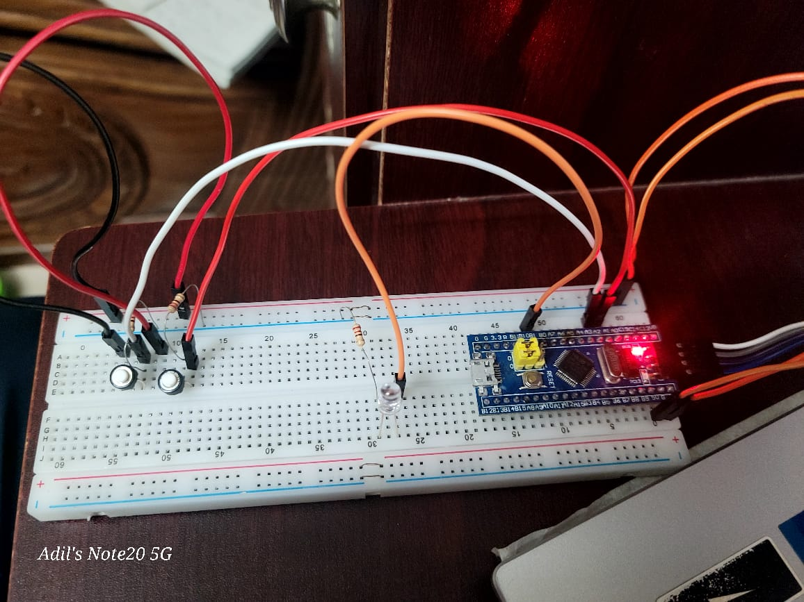

Lab Performance Evaluation 02
Lab Task Q2
Question: Circuit Design with STM32 based embedded system which takes 1 input via Potentiometer and gives output via RGB LED. When the potentiometer is in high state the RED light will be turned on, otherwise blue light will turn on.

Solution (Code):
// Roll-2103064
#include "stm32f10x.h"
void delay_ms(uint32_t ms);
void gpio_init(void);
void adc_init(void);
uint16_t adc_read(void);

int main(void)
{
gpio_init();
adc_init();
while (1) {
uint16_t adc_value = adc_read();
if(adc_value>=4000)
{
GPIOB->ODR |=(1UL<<0);
GPIOB->ODR &=~(1UL<<1);
}
else
{
GPIOB->ODR |=(1UL<<1);
GPIOB->ODR &=~(1UL<<0);
}
}
}
void gpio_init(void)
{
RCC->APB2ENR |= (1 << 3);
GPIOB->CRL &= ~(15UL << 0 | 15UL<<4);
GPIOB->CRL |= (1UL << 0 | 1UL<<4);
RCC->APB2ENR |= (1 << 2);
GPIOA->CRL &= ~(15UL << 0);
GPIOA->CRL |= (0UL << 0);
}
void adc_init(void) {

RCC->APB2ENR |= (1 << 9);
ADC1->CR2 |= (1 << 0);
for (volatile int i = 0; i < 1000; i++);
ADC1->SMPR2 |= (0x7 << 0);
}
uint16_t adc_read(void)
{
ADC1->SQR1 = (1 - 1) << 20;
ADC1->SQR3 = (0 << 0);
ADC1->CR2 |= (1 << 0);
while (!(ADC1->SR & (1 << 1)));
return ADC1->DR;
}

Output (Pics of Breadboard):

